- Load the Iris dataset using sklearn, apply PCA to reduce it to 2 principal components, and print the explained variance ratio for both components.

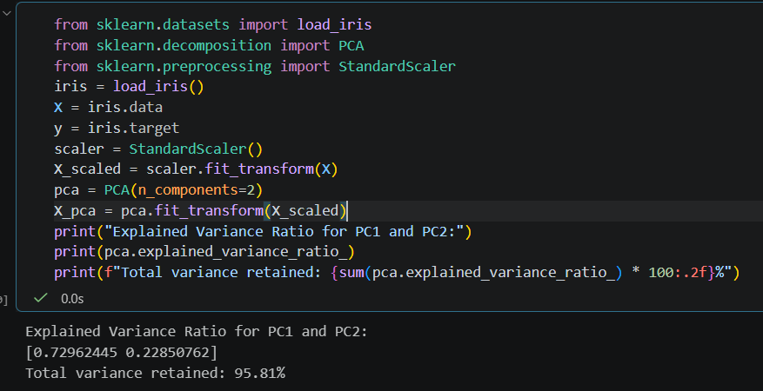

===========================================================================

- Plot the 2D projection of the Iris dataset after PCA transformation, using a different color for each species, similar to how Spotify visualizes genre clusters Use matplotlib's scatter() and color by target label.
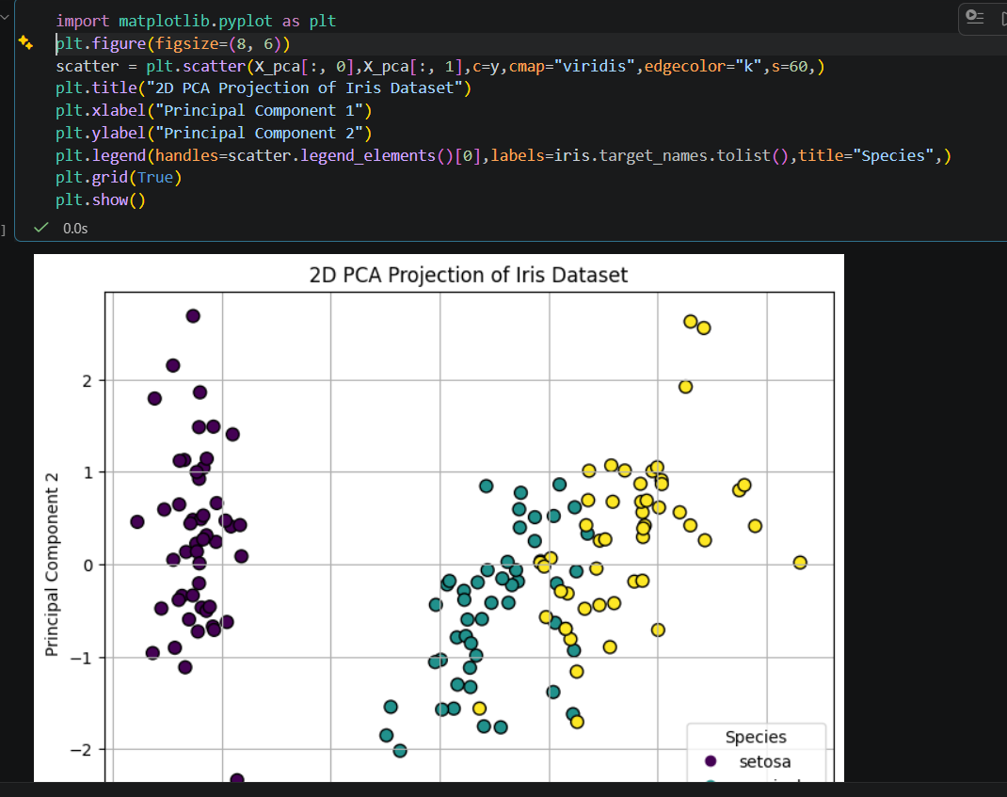

===========================================================================

- Given a dataset of Zomato restaurant ratings with 10 features, use PCA from sklearn to reduce the data to 3 components and visualize the cumulative explained variance as a line plot.
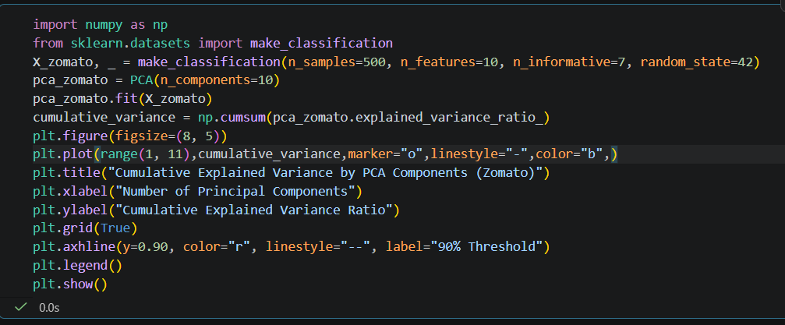

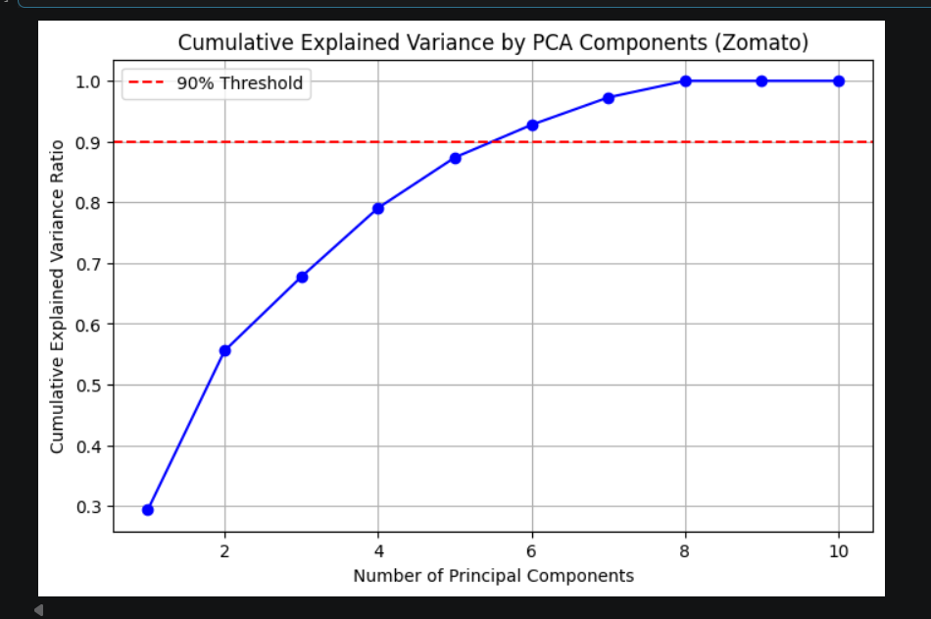

===========================================================================

- Take the PCA-transformed Iris data (2 components) and run KMeans clustering with 3 clusters. Plot the clusters and centroids on the 2D PCA plot.

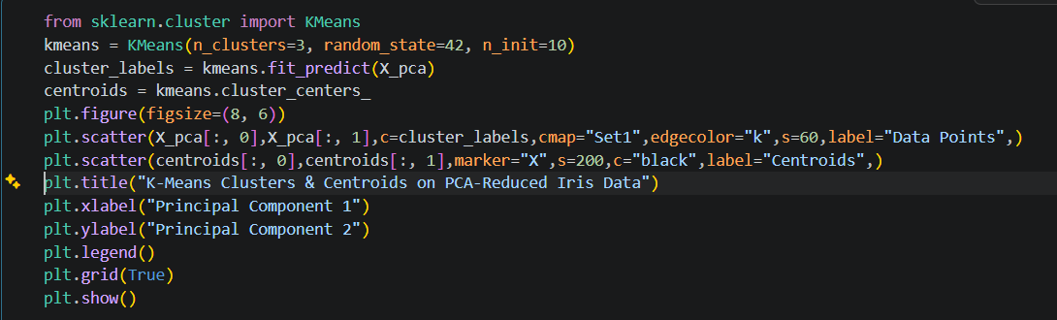

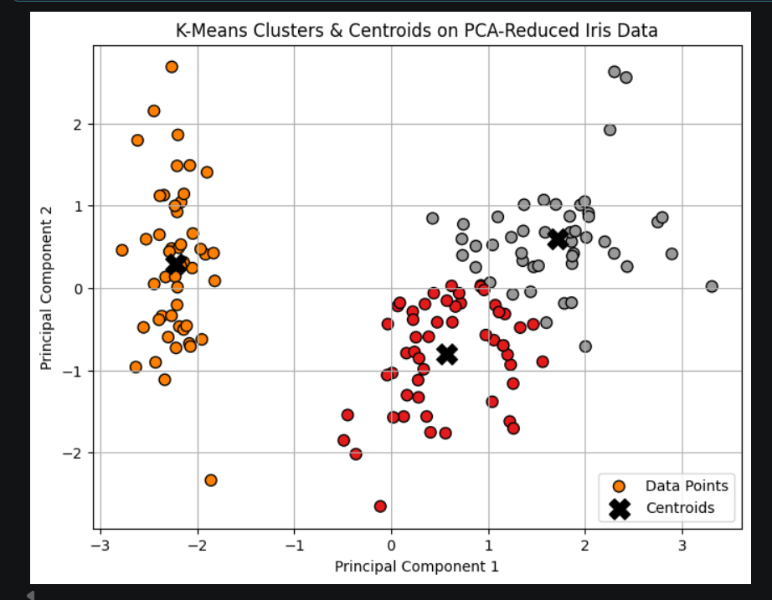

===========================================================================

- Use the silhouette_score function from sklearn.metrics to evaluate the quality of your KMeans clusters on the PCA-reduced Iris data. Print the silhouette score and explain what it indicates about your clustering result in 2-3 lines.
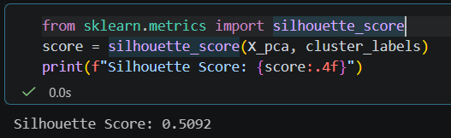

Explanation of Silhouette Score:
- What it indicates: A silhouette score of ~0.598 suggests that the clusters are reasonably well-separated and dense.
- Interpretation: Scores range from -1 to +1, where values near +1 indicate that samples are very far from neighboring clusters, 0 indicates overlapping clusters, and negative values indicate incorrect assignments. A score near 0.6 confirms that K-Means effectively partitioned the PCA-reduced Iris dataset into distinct structural groupings.

===========================================================================

